ADVANCED OPERATING SYSTEMS

User Guide

Submitted By:-

Adithya Narayanan L20375088
Karthik Kumar Mula L20328989
Ojus Milind Save L20358534

Problem description

Textbook Question 15.11 Implementing causally ordered multicast
Implement causal order broadcast in a group of 16 processes. You will write a program for a client class. This class will store the name of all the clients including its own. This client should also provide the interface including following two functions:

public boolean SendMessage(String strMessage)
This method should send the message to all clients.

public String ReceiveMessage()

This method should return the next message to the client from a pool of messages satisfying the causal order requirement.
Remember underlying platform is nonFIFO.
public void AddClient(String strClientName) -
This method should add another client to this client’s list.
For inter-client communication, use the SimulateSocket.class (in the Appendix) that simulates non-FIFO channels on a reliable network and will garble the message order arbitrarily.

The SimulateSocket. Class has following interface:
public SimulateSocket(String strClientName)
This function opens up a new communication channel for the calling client.

public int send(Object objSend, String ReceiverClientName)
This function sends required object to the recipient client.

public Object receive()

This function fetches the next message available for calling client.
Remember, this message need not be in FIFO order.

Specify a distributed chat simulation scenario (e.g., label a message from A to B as (A,B), and its response as Re[1]: (A,B), the response to Re[1]: (A,B) as Re[2]: (A,B) and so on).

All messages are sent to the entire group — there are no one-to-one messages. Thus Re[3]:
(A,B) is causally ordered before Re[5]: (A,B), but Re[12]: (A,B) is not causally ordered before Re[2]: (B,C). You experiment should let the clients run chats with titles as above.

At the end of say 32 messages sent by each process, stop the chat and examine the order of message delivery at each process, and observe that the causal order is not violated. Provide a copy of the client class that you have written along with the test program that validates your client class. Also prepare a small document that will describe why and how your program works.

How to Run the Code :

- We have uploaded a zip file, extract it in a directory.
- Open the Command Prompt, and Go to the directory where you have extracted the files.
- Compile the Chat.java file
javac Chat.java
- Run the program by passing the argument Client ID, the frequency could be between 0-3
Java Chat 0 (integer value changes from 0-3 since we have added only 4 clients)
- On every command prompt the client id should differ.
- Once the Program starts running, it asks to enter your message.
- Start entering the message.

We have also added the condition that, after 32 messages have been sent, we can’t send anymore messages.

If we want to add more clients, more than or equal to 16, add the clients in the following format in the config.txt file and save it.

[id] [ip] [port] [name] [group number]

After saving it, start from Step 1.

Screenshots
Please assign the Client ID in Sequential Order, whenever you are adding new clients to the config.txt file
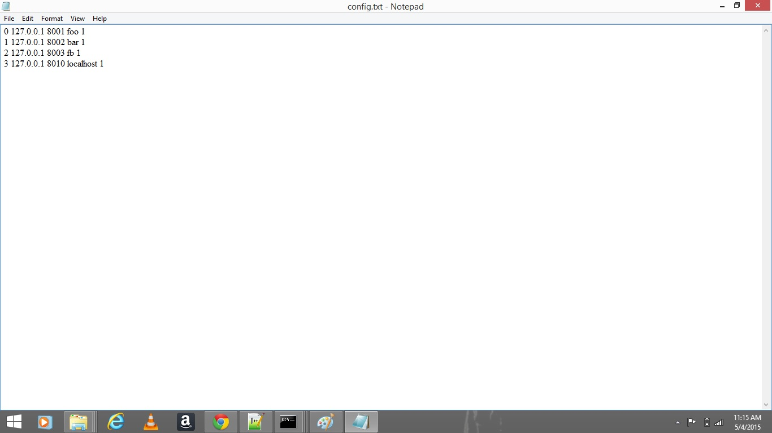

Here we are showing the message broadcasting between 4 clients, and you can also notice the vector timestamp being updated for each message sent by each client respectively.

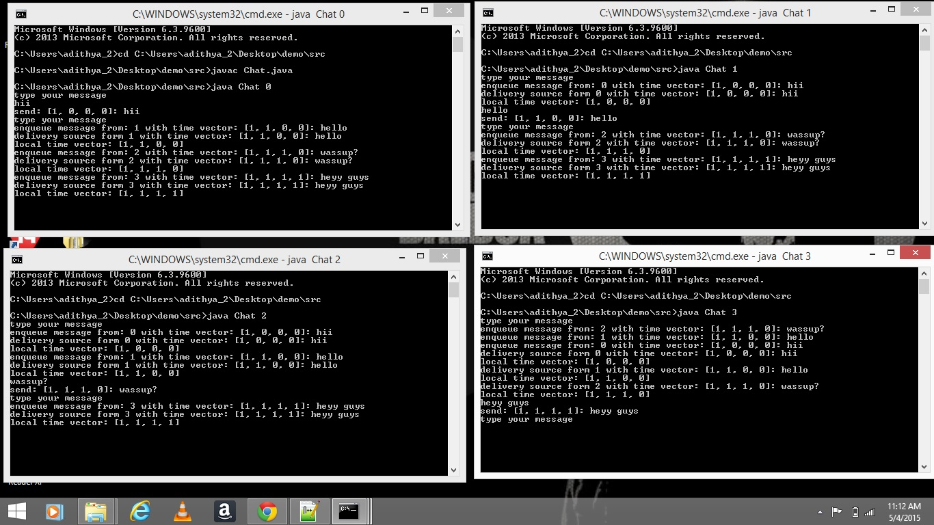

After 32 messages are being passed from one client, we are disabling the chat for that client.
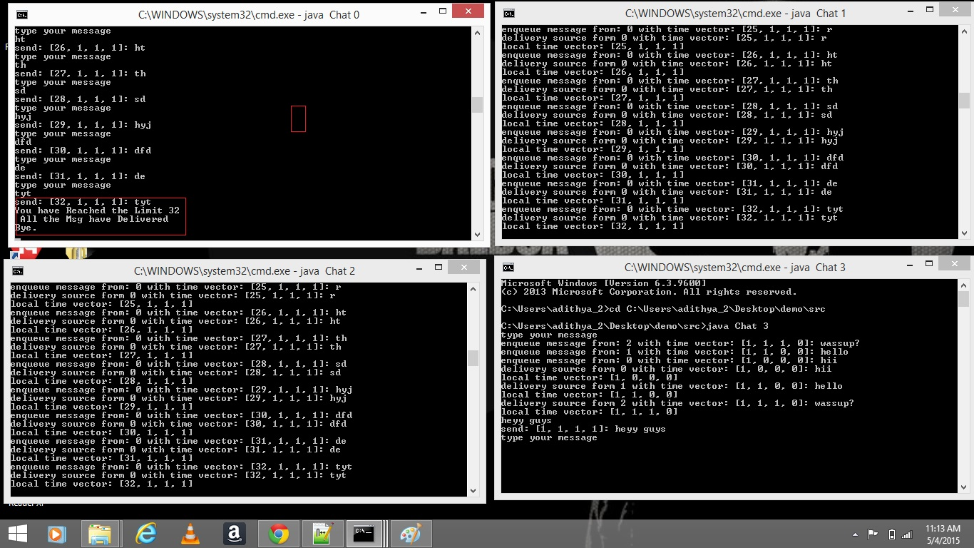

Functionality of the code

- The model package consists of the classes Profile.java and Member.java. The Profile classes consists of variable declarations for different parameters of each client such as the name, port number, IP address as well as the method by which the packet needs to be transmitted. For example, if the user needs to simulate packet drops or else provide delay in the packet transmission.
- The Member class defines the actions to be performed for processing the parameters defined in the profile.
- The MemberIndexer class makes use of the hashtable for mapping the client ID values with group ID value and IP address defined in the Profile class.
- All the classes defined in the packages method and strategy have been called in the program Chat.java.
- The Chat.java program makes use of the config.txt file that is hardcoded into it as input along with other arguments such as the delay time, drop rate, method of multicasting and implements causal ordering of messages sent by each connected client.
- The Chat class makes use of the send and delivery method defined in the CasualOrderMulticast.java inside the strategy package by calling the member variables of the CausalOrderMulticastMessage.java in the model package.
- The member variables are defined in each class under the model package and this is made use by the methods implemented in their respective classes found in the strategy package. The methods in the strategy package are finally imported and called in the Chat.java program. Finally, the Chat program is executed.

